Quiz 1 20/2/2020

In the Hypothetical Machine the contents of memory was as shown. And PC contents is 300. Show the contents of memory and PC, AC, IR after execute three instructions (three fetch cycle and there execute cycle)

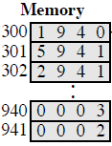

**ANSWER**:

**First Instruction:**

**Fetching:**

**AC: 0000 IR: 1940 PC: 300**

**940: 0003 941: 0002**

**Execution:**

**AC: 0003 IR: 1940 PC: 300**

**940: 0003 941: 0002**

**Second Instruction:**

**Fetching:**

**AC: 0003 IR: 5941 PC: 301**

**940: 0003 941: 0002**

**Execution:**

**AC: 0005 IR: 5941 PC: 301**

**940: 0003 941: 0002**

**Third Instruction:**

**Fetching:**

**AC: 0005 IR: 2941 PC: 302**

**940: 0003 941: 0002**

**Execution:**

**Ac: 0000 IR: 2941 PC: 302**

**940: 0003 941: 0005**

Show the contents of PC , AC and IR and memory after the execution of each instruction of the following program on the Hypothetical Machine:

300 LOAD 550

301 ADD 551

302 STORE 600

Where the contents of memory at 550 is 3 and at 551 is 4.

**ANSWER:**

***First Instruction:***

***Fetching:***

***AC: 0000 IR: 1550 PC: 300***

***550: 0003 551: 0004 600: 0000***

***Execution:***

***AC: 0003 IR: 1550 PC: 300***

***550: 0003 551: 0004 600: 0000***

***Second Instruction:***

***Fetching:***

***AC: 0003 IR: 5551 PC: 301***

***550: 0003 551: 0004 600: 0000***

***Execution:***

***AC: 0007 IR: 5551 PC: 301***

***550: 0003 551: 0004 600: 0000***

***Third Instruction:***

***Fetching:***

***AC: 0007 IR: 2600 PC: 302***

***550: 0003 551: 0004 600: 0000***

***Execution:***

***AC: 0000 IR: 2600 PC: 302***

***550: 0003 551: 0004 600: 0007***

The following figure provide the main characteristics of Hypothetical Machine.

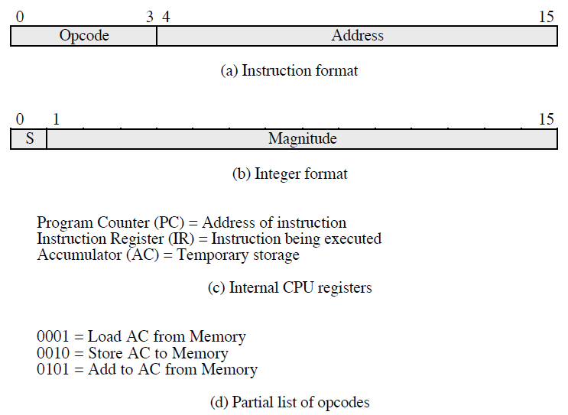

The hypothetical machine also has two I/O instructions:

0011 = load AC from I/O

0111 =store AC to I/O

In these case, the 12-bi address identifies a particular I/O device. Show the program execution for the following program:

1. Load AC from device 5.

2. Add contents of memory location 940.

3. Store AC to device 6.

Assume that the next value retrieved from device 5 is 3 and that location 940 contains a value of 2.

**ANSWER:**

**MEMORY**

|  |  |
| --- | --- |
| **300** | **3005** |
| 301 | 5940 |
| 302 | 7006 |

**After executing the three instructions:**

**device 5: 0003**

**940: 2**

**device 6: 0005**